**Zabbix Email Setup**

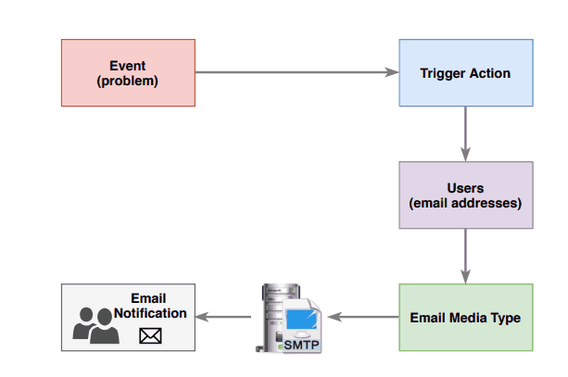

Zabbix email notification workflow

**Gmail Integration**

First, we need to enable your Gmail account to receive connections from external programs.

Login to this link <https://myaccount.google.com/lesssecureapps>

Select the option to enable the use of less secure applications.

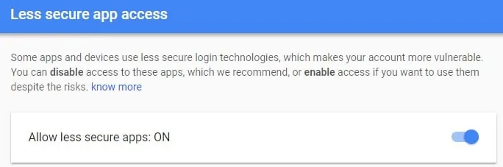

Now, we need to test if we can use the Linux command-line to send an email using Gmail.

Use the following commands to install the required packages.

**# sudo apt-get update**

**# sudo apt-get install ssmtp**

Edit the ssmtp.conf file to connect to our Gmail account.

**# vi /etc/ssmtp/ssmtp.conf**

**root=******@gmail.com**

**mailhub=smtp.gmail.com:465**

**FromLineOverride=YES**

**AuthUser=******@gmail.com**

**AuthPass=******123**

**UseTLS=YES**

Use the following command to send an email using the command-line.

**# echo "E-Mail using the command-line" |** [**ssmtp*******@gmail.com**](mailto:ssmtp*******@gmail.com)

Now, check your Gmail inbox for the test message that you just sent.

If the test was unsuccessful due to an authorization error, you need to access the following URL

<https://accounts.google.com/DisplayUnlockCaptcha> and then allow access.

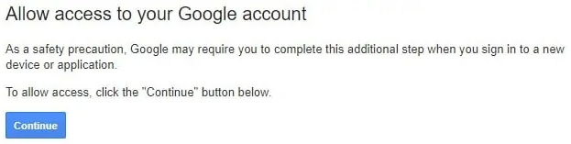

Once you have given the access, try to send the email using the command line mentioned in the above steps.

Now login to the Zabbix with the credentials.

After a successful login, you will be sent to the Zabbix Dashboard.

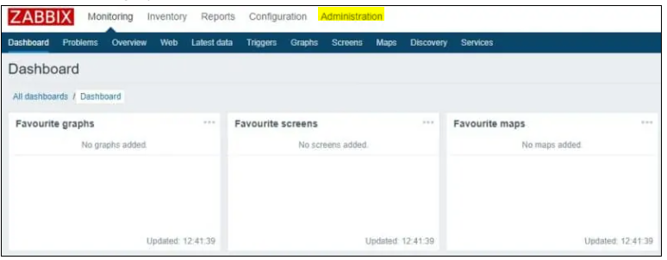

On the dashboard screen, access the Administration menu and select the **Media types** option.

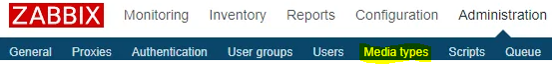

On the Email properties screen, you need to enter the following configuration.

• SMTP server - Enter the E-mail server IP address or Hostname.

• SMTP server port - Enter the SMTP TCP port of the e-mail server.

• SMTP helo - Enter the domain name of your e-mail address.

• SMTP email - The e-mail address that will send Zabbix notifications.

• Connection Security - The security protocol that should be used to connect to the e-mail server.

• Authentication - The username and password of the e-mail account that will send Zabbix notifications.

• SMTP server - SMTP.GMAIL.COM

• SMTP server port - 465

• SMTP helo - gmail.com

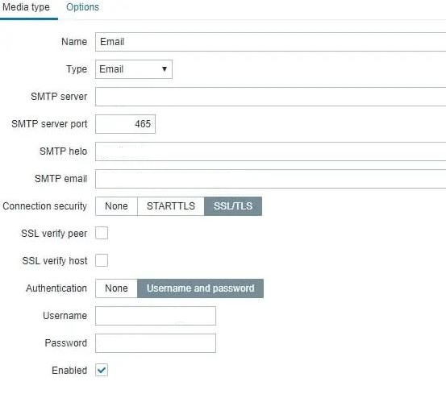

Click on the Update button.

On the dashboard screen, access the Configuration menu and select the Action option.

Locate and the option named: Report problems to Zabbix administrators and set the status to enable, It will then turn on the word Enabled in green.

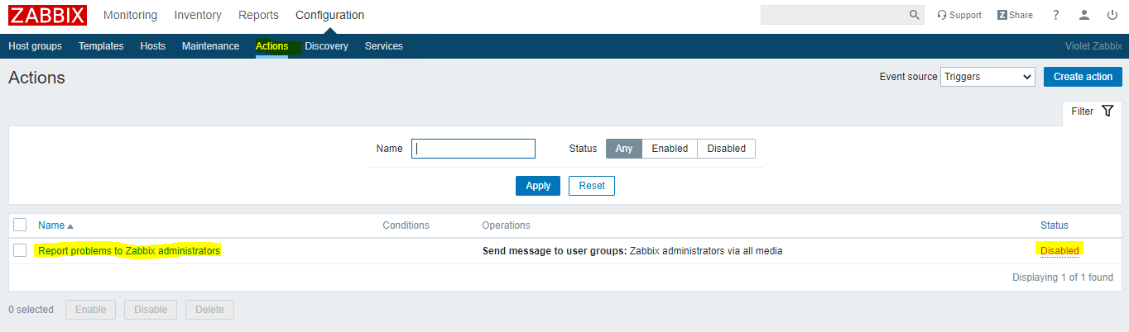

This will configure Zabbix to send e-mail notifications to the users that are members of the Zabbix Administrator group.

By default, only the user Admin is a member of the Zabbix administrators’ group.

By default, the Admin user has no e-mail address associated to the account.

Now, we need to associate an e-mail address to the Admin account.

Login on the Zabbix web interface as the Admin user.

On the top right part of the screen, access the user profile settings.



On the user profile screen, access the Media tab and add a new Email configuration.

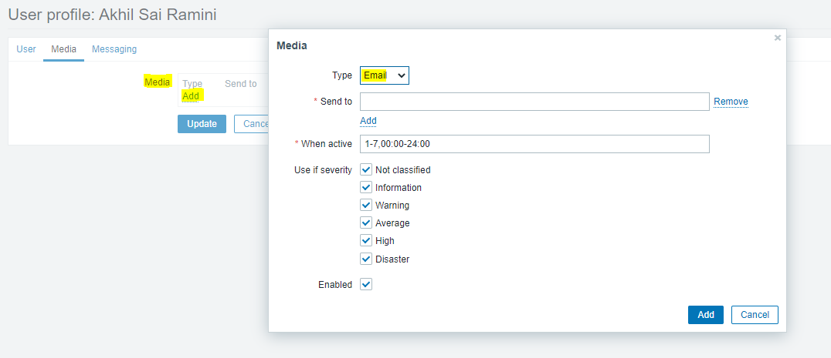

Add and save it. Thus, we have configured the Zabbix server e-mail notification.

**Testing Zabbix Notification**

In our example, we are going to create a fake ICMP problem.

On the dashboard screen, access the Configuration menu and select the Host option.

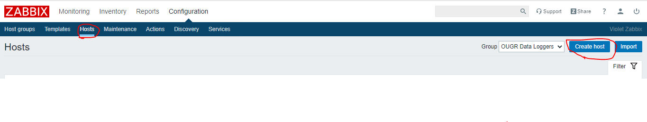

On the Host configuration screen, you have to enter the following information:

• Host Name - TEST

• Visible Hostname - TEST

• New group - TEST

• Agent Interface - 5.5.5.5

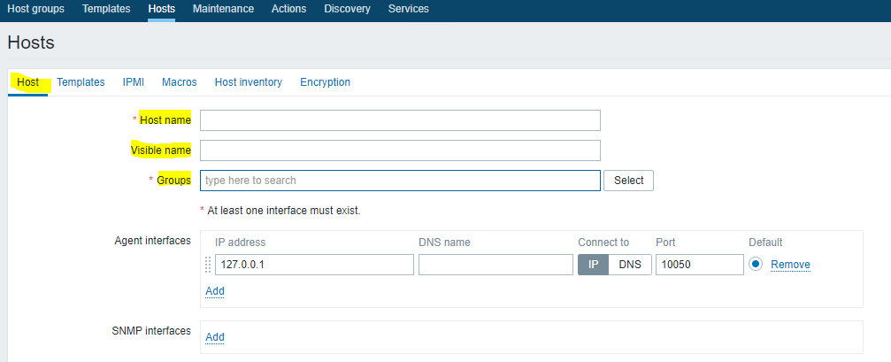

Now access the Templates tab and add the following template in Link new templates.

• Template module ICMP Ping

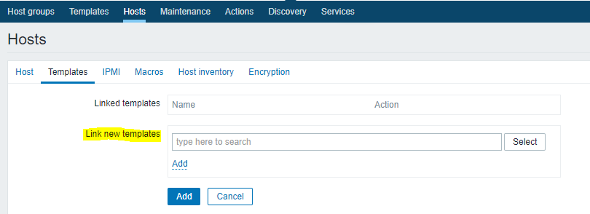

After finishing the host configuration go back to the Zabbix dashboard initial screen and wait 5 minutes.

Wait for the ICMP problem trigger to activate.

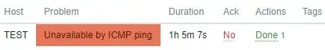

Take a look at the email inbox of user Admin.

Check if the Zabbix server sent you an email notification reporting this problem.

If you have received the mail, then the test is success.

**Zabbix SMS Setup**

Zabbix supports the sending of SMS messages using a serial GSM modem connected to Zabbix server's serial port.

Ensure the following things

* The speed of the serial device (normally /dev/ttyS0 under Linux) matches that of the GSM modem. Zabbix does not set the speed of the serial link. It uses default settings.
* The 'zabbix' user has read/write access to the serial device. Run the command ls –l /dev/ttyS0 to see current permissions of the serial device.
* The GSM modem has PIN entered and it preserves it after power reset. Alternatively, you may disable PIN on the SIM card. PIN can be entered by issuing command AT+CPIN=“NNNN” (NNNN is your PIN number, the quotes must be present) in a terminal software, such as Unix minicom or Windows HyperTerminal.

Zabbix has been tested with these GSM modems:

* Siemens MC35
* Teltonika ModemCOM/G10

**CONFIGURATION**

To configure SMS as the media type:

1. Go to Administration → Media types
2. Click on Create media type (or click on SMS in the list of pre-defined media types).

The Media type tab contains general media type attributes:

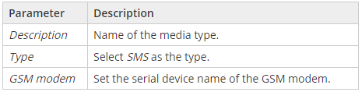

The Options tab contains alert processing settings that are common for all media types. Note that parallel processing of sending SMS notifications is not possible.

**USER MEDIA**

To assign a phone number to the user:

* Go to Administration → Users
* Open the user properties form
* In Media tab, click on Add

User media attributes:

